Ardublock by SumoBoy installation

1. Check if Arduino IDE is already installed on tour PC

(Default location is: C:\Program Files(x86) \Arduino)

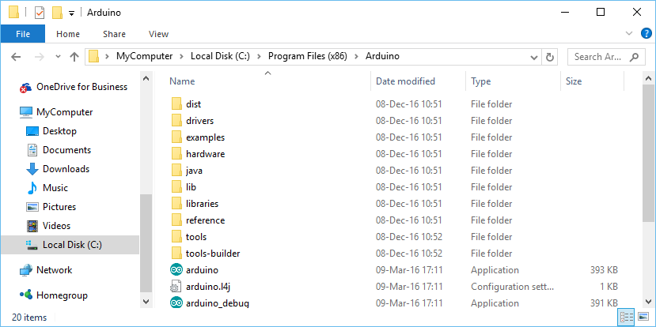

1. Download Setup file:
   1. If you don’t have Arduino IDE:

<https://github.com/AleksandrsKorsunovs/Ardublock-for-Sumoboy/raw/master/ArduBlockSumoBoy%2BArduinoSetup.msi>

* 1. If you have Arduino IDE:

<https://github.com/AleksandrsKorsunovs/Ardublock-for-Sumoboy/raw/master/ArdublockSumoboySetup.msi>

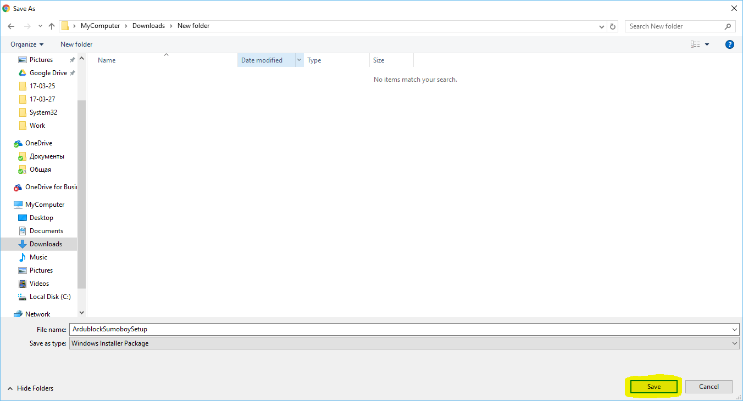

1. 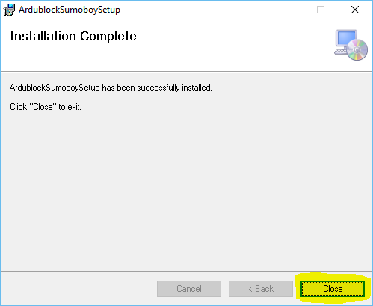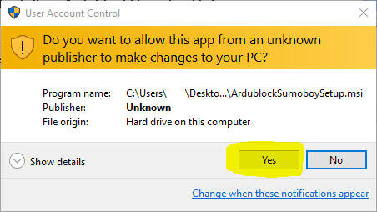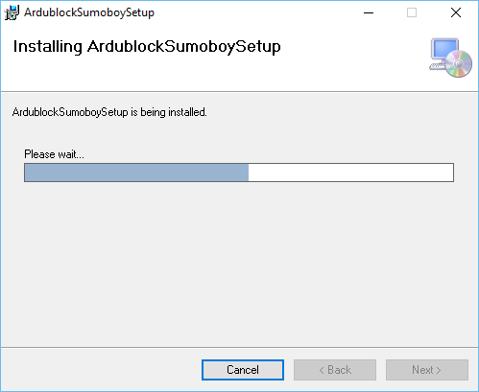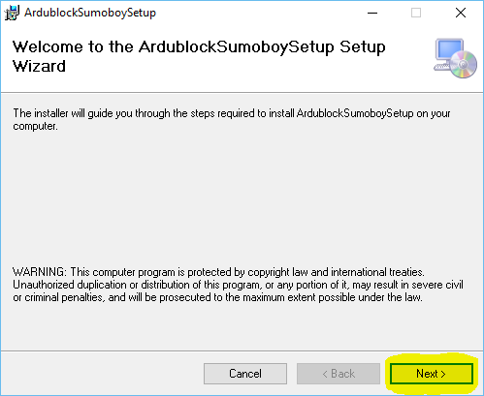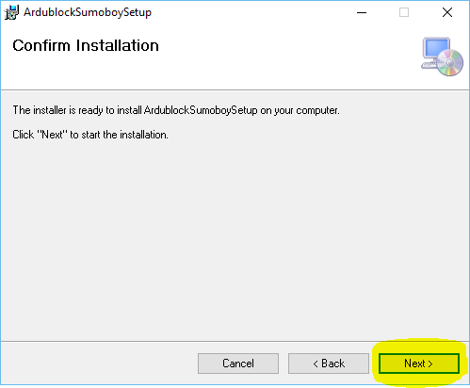Launch Setup file and install
2. Ardublock for SumoBoy tool is ready to use

Using Ardublock

1. 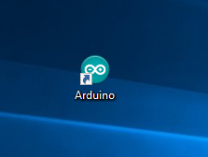Launch ArduinoIDE
2. Connect SumoBoy robot via USB to PC
3. Make sure correct PORT and BOARD are selected (Port number is individual for each PC, but it should have “(Arduino/Genuino Micro)”)

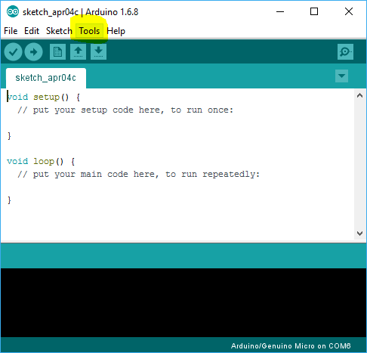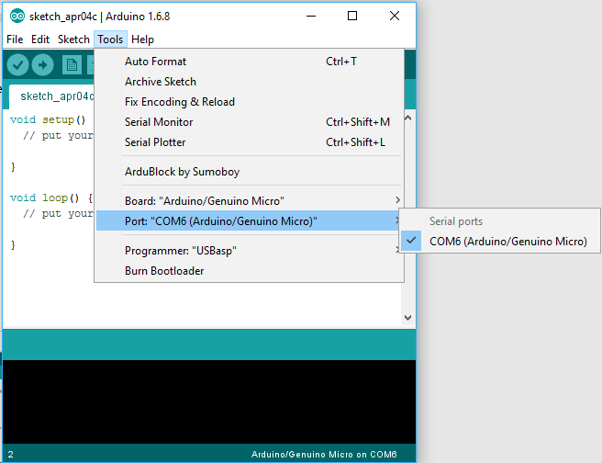

1. Create and save new project

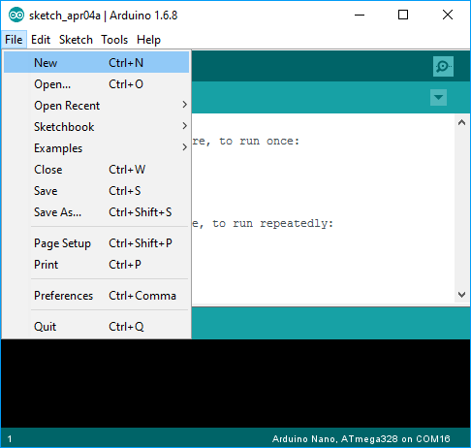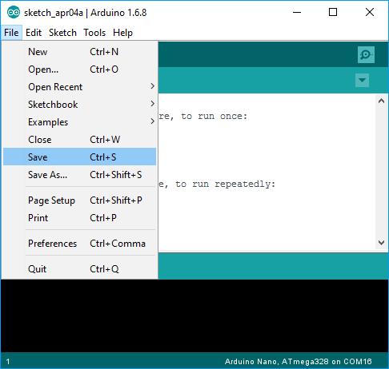

1. Launch Ardublock tool

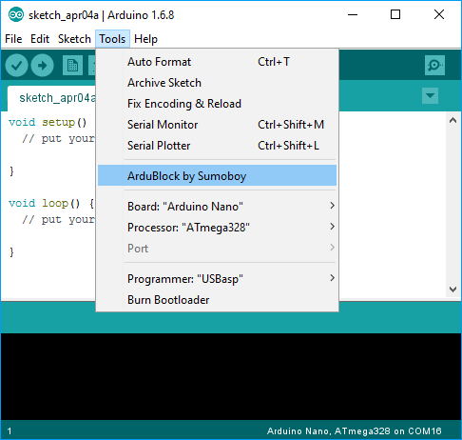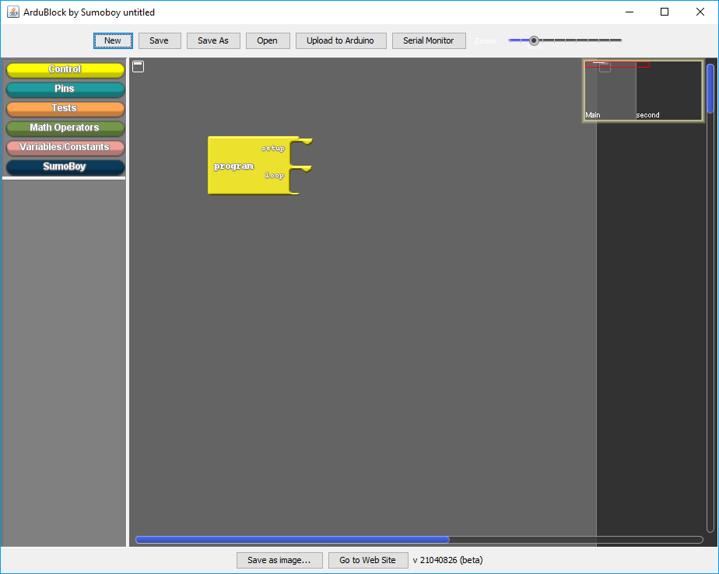

1. Create some BLINK program
   1. Select “SumoBoy” drawer (Left click)

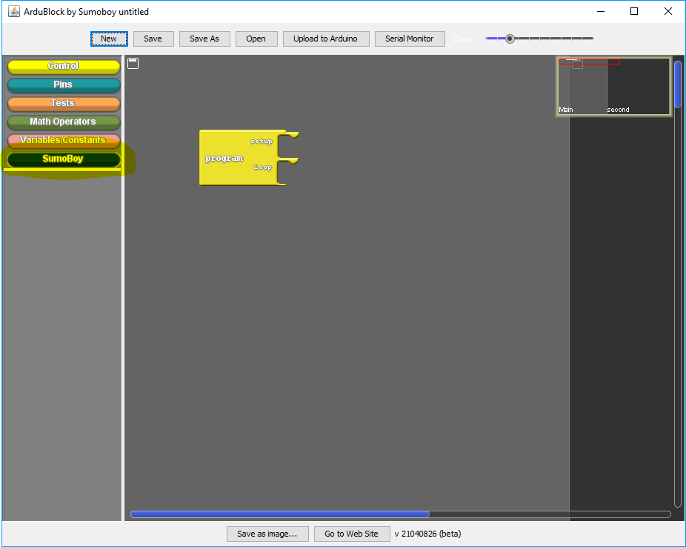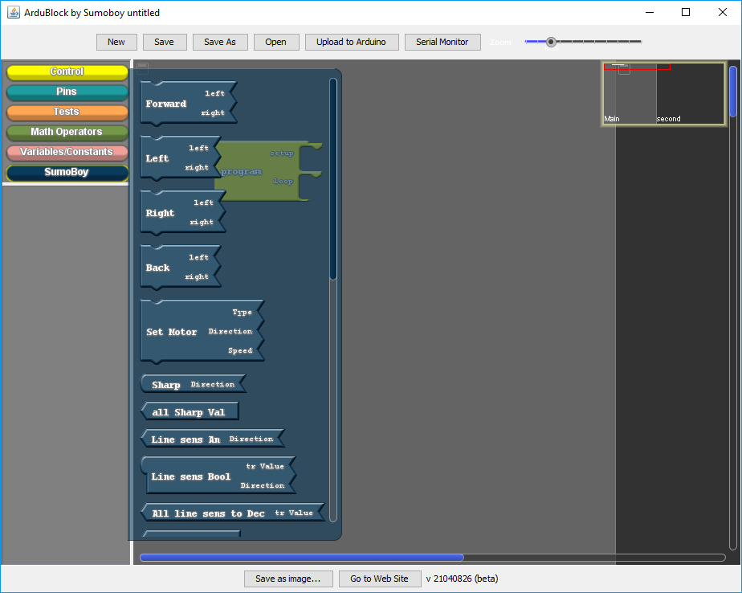

* 1. Find and drag to workspace “Turn Led” block

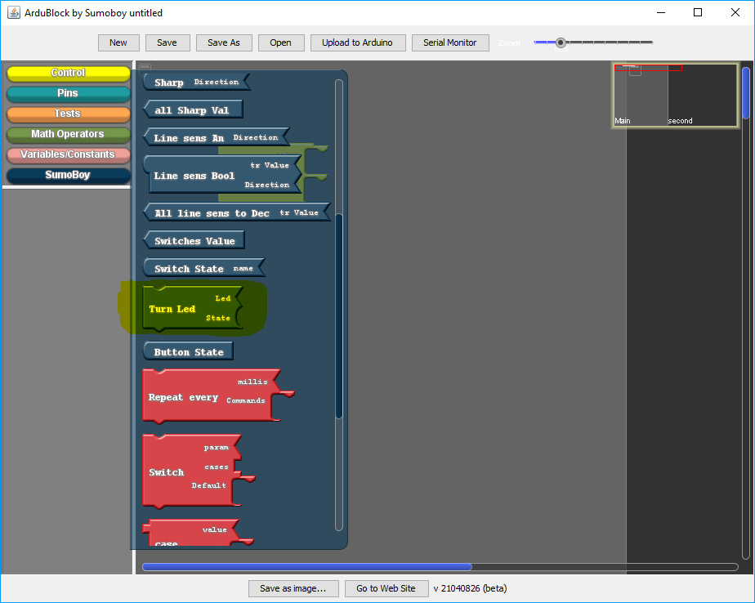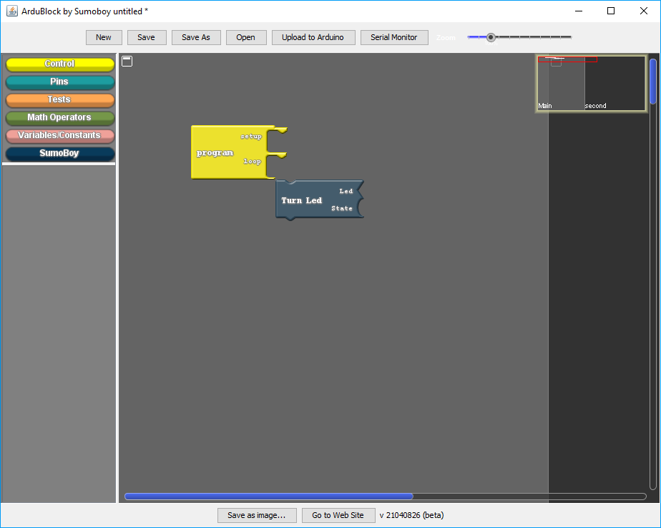

* 1. Connect it to “Program” block’s LOOP connector

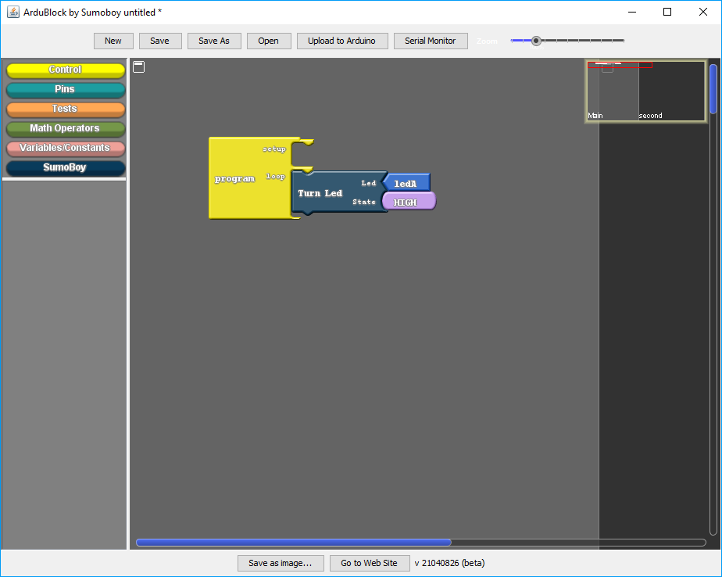

* 1. Set LED and its start STATE

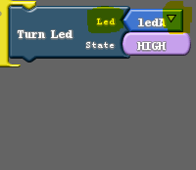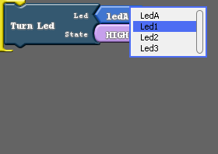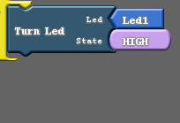

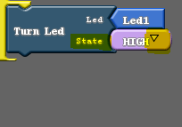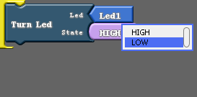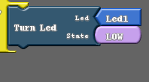

* 1. Select “Control” drawer

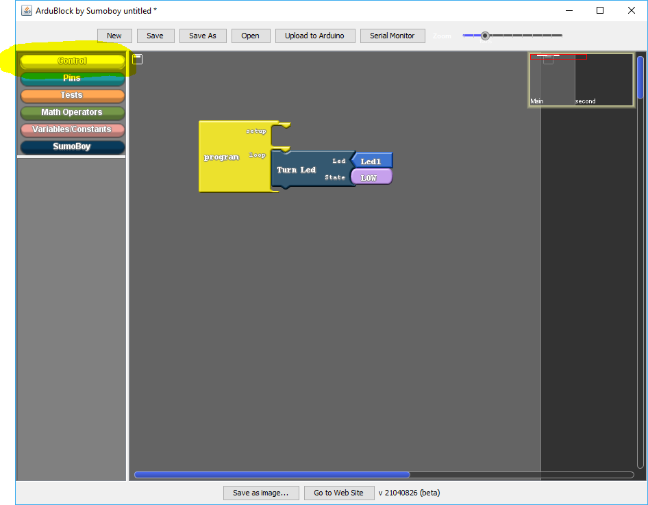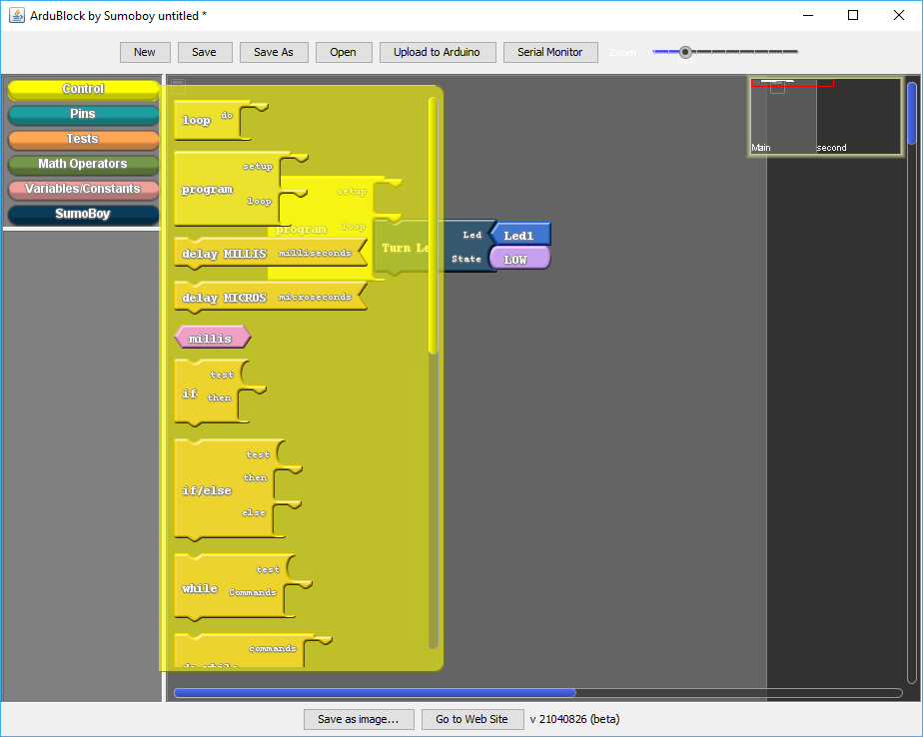

* 1. Find and drag to workspace “delay MILLIS” block

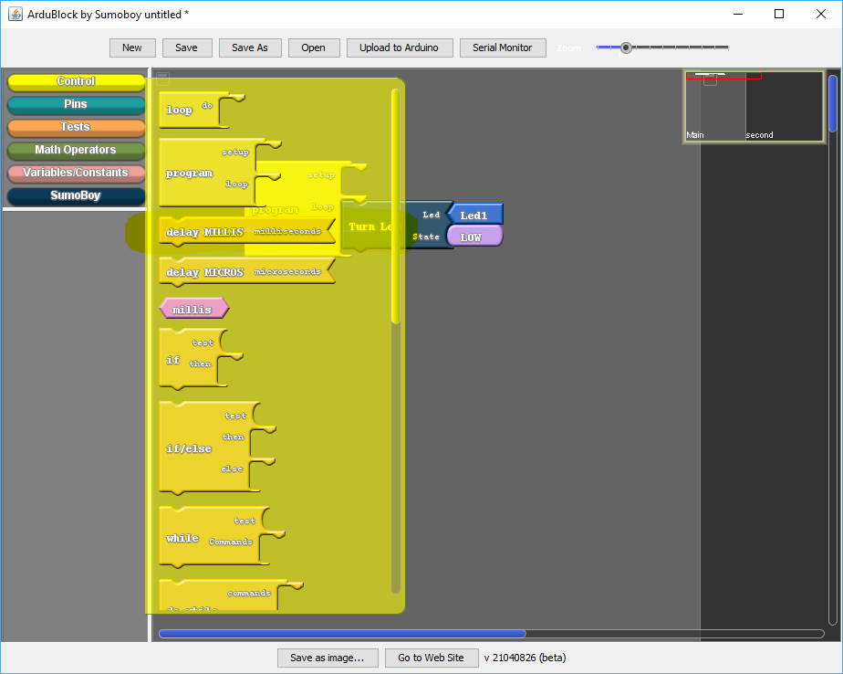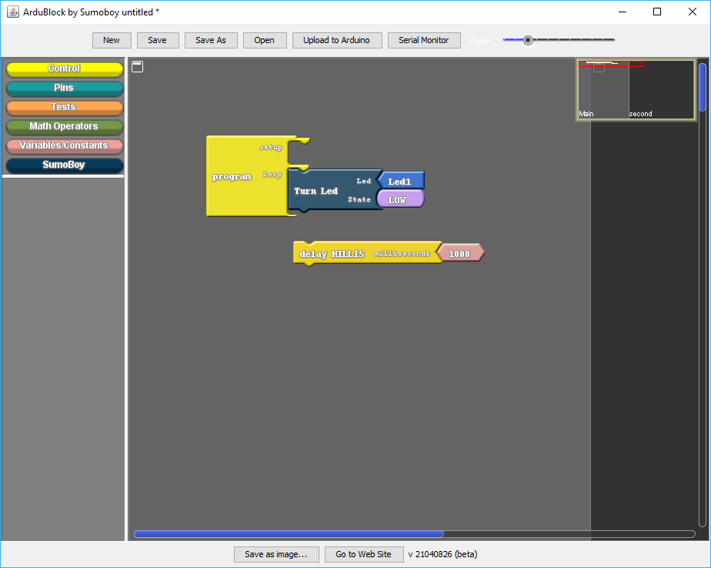

* 1. Connect it to “Turn Led” block

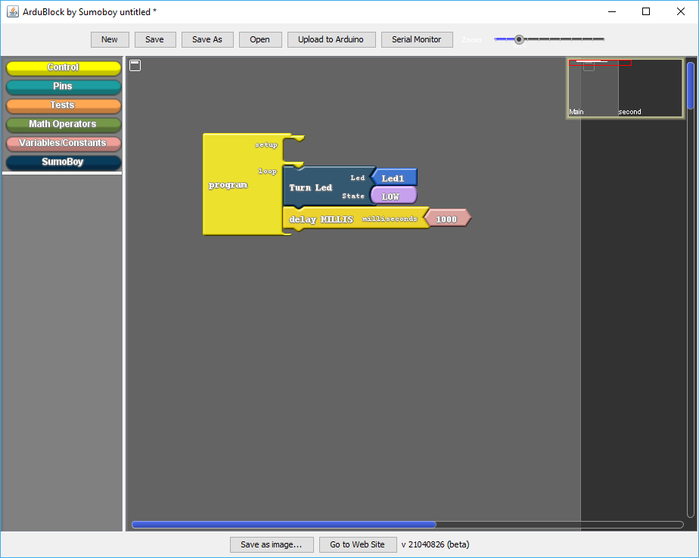

* 1. Type in “delay MILLIS” interval in millisecond (1000 ms = 1 s) (Left click on “Number” block -> Type -> press “ENTER”)

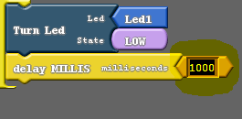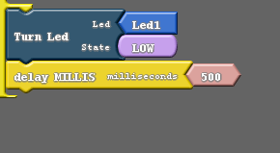

* 1. Type that little formula in comment (Right click on block-> Comment -> Type comment)

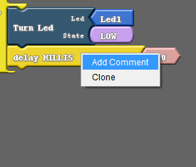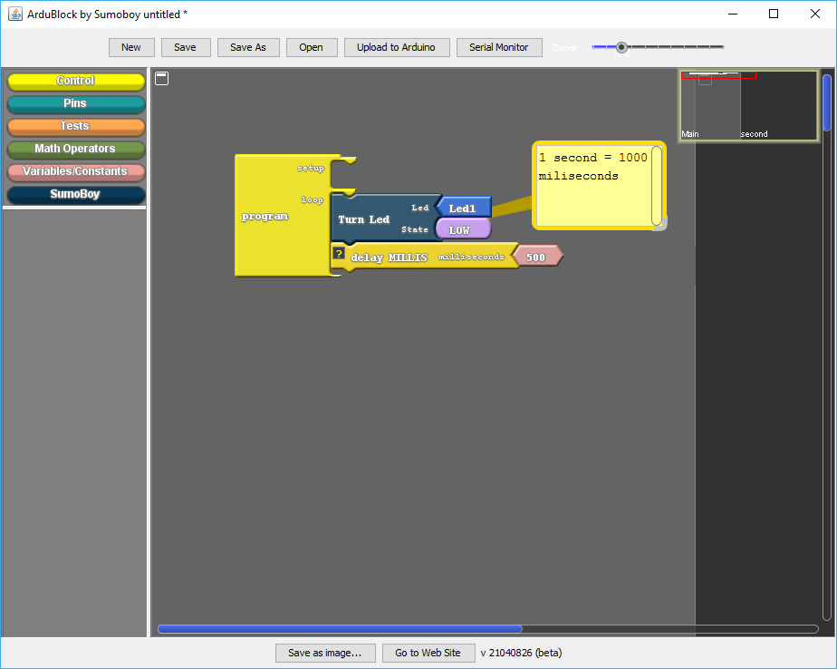

* 1. Clone “Turn Led” block and “delay MILLIS” block (Right click on “Turn Led” block-> Clone. Clones selected block and all block connected to it)

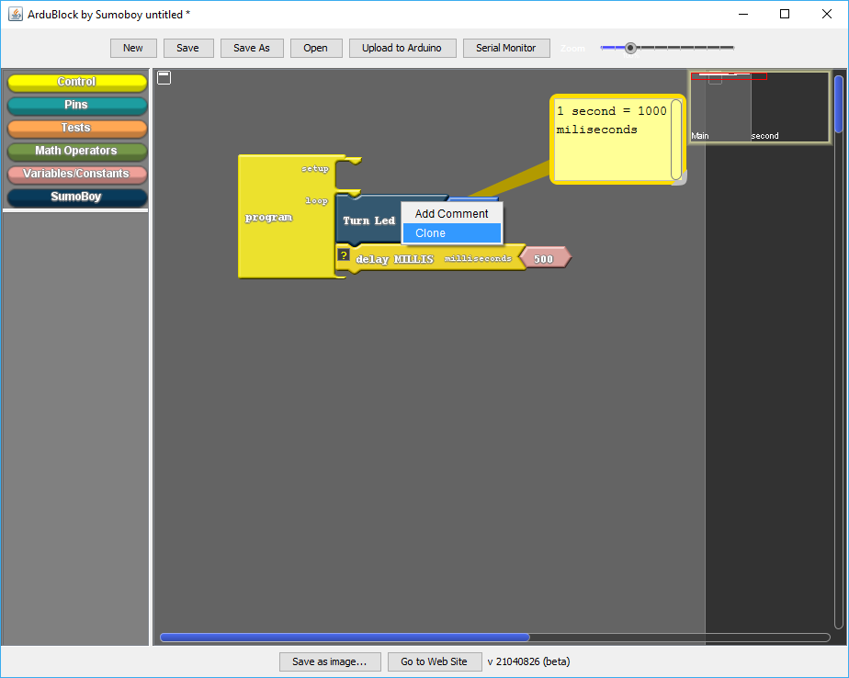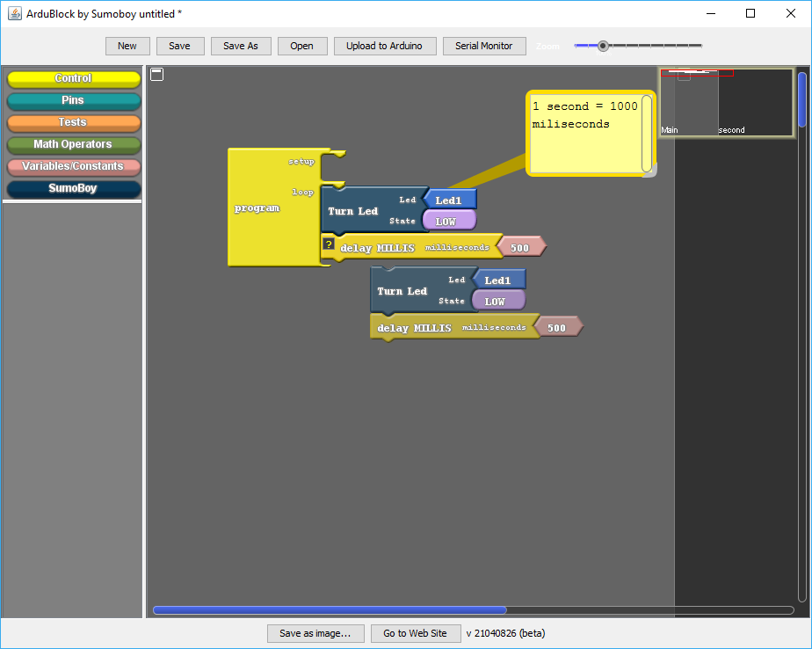

* 1. Connect copied blocks to “delay MILLIS” block

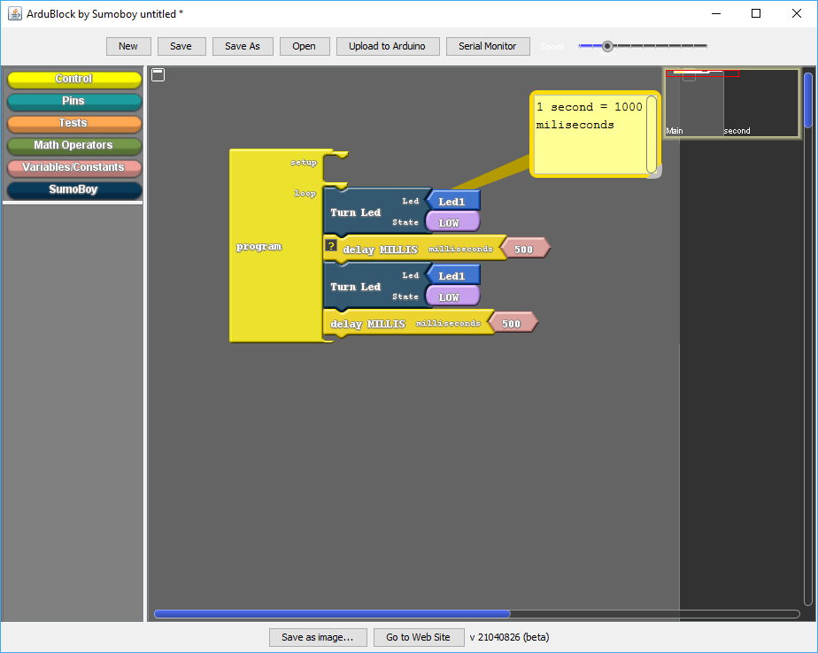

* 1. Change STATE in copied “Turn Led” block to opposite

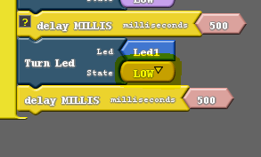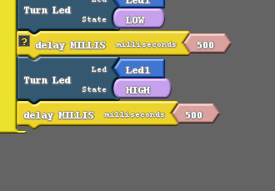

* 1. If you are not sure what block or connector does, hover mouse over it – most blocks have description, which appears on hover

1. Program is ready. To upload it to SumoBoy press “Upload To Arduino” button (Make sure PORT and BOARD are selected correctly)

